Deliverable #3

Group name: liam-n-pham

# Introduction

This report will deliver the comprehensive information about the approaches in python and excel for hypothesis testing for the Sales and Customers dataset and provide the rationale behind all decisions.

# Dataset Overview

**Data Structure**

**Customer Data** (Customers_v4.csv)

* **Records**: 1,001 customers
* **Attributes**: 9 variables including Customer ID, Demographics (Age, Gender), Geographic (City, Province, Region), and Membership information (Level, Tenure)
* **Key Fields**: Customer ID (unique identifier), Membership Level (Standard, Gold, Platinum), Customer Age (18-100 years), Tenure (years as customer)

**Sales Transaction Data** (Sales_Cleaned from the Deliverable #2)

* **Records**: 25,000 transactions
* **Date Range**: January 24, 2023 to August 20, 2025
* **Attributes**: 13 variables including Transaction ID, Customer ID, Product details (Category, Item), Financial metrics (Unit Price, Unit Cost, Discount Rate, Total Spent), and Operational data (Location, Payment Method, Date)

# Project Structure

# Hypothesis testing Report

## Hypothesis 1:

## Hypothesis 2: Gender Differences in Spending

### Our data:

* Total male customers: n₁ = 489, Mean score: x̄₁ = 12528.31, Standard Deviation s₁ = 10159.25
* Total female customers: n₂ = 511, Mean score: x̄₂= 12542.60, Standard Deviation s₂ = 10024.61

### Research Question

* Is there a significant difference in average spending between male and female customers?

### Formulate the Hypotheses

We start by defining our null and alternative hypotheses

* **Null hypothesis (H₀):** There is no difference in average spending between male and female customers.
  + In mathematical terms: μ_male = μ_female or μ_male - μ_female = 0
* **Alternative hypothesis (Hₐ):** There is a difference in average spending between male and female customers
  + In mathematical terms: μ_male ≠ μ_female
* **This is a two tailed test**

### Check the Assumptions

Before running the test, we must verify its key assumptions

1. **Independence**: The observations within each group and between groups are independent. Because each customer’s spending is recorded independently, one customer’s spending does not influence another customer’s spending and the samples are randomly selected of the entire customer dataset.
2. **Normality**: The dependent variable (spending) should be approximately normally distributed within each group. We would check Q-Q plots for each group (male and female) or run a Shapiro-Wilk test for normality. The sample size >= 30 in each group then we could use Central Limit Theorem for assuming approximate normality
3. **Equal Variances (Homoscedasticity):** We need to decide which type of t-test to use. We can use Levene’s test or a simple rule of thumb: if the ratio of the 2 sample variances is < 4.
   * Variance Ratio = (s₂² / s₁²) = 103210411.56 / 100492791.42 ≈ 1.0270**.** The ratio is less than 4, so we will proceed with a standard two sample t-test assuming equal variances

### Conduct the Test

* We will use significance level of **α = 0.05**
* We calculate the **pooled standard deviation** combines the variability from both groups:

s_p = √( ((n₁ - 1)s₁² + (n₂ - 1)s₂²) / (n₁ + n₂ - 2) )

s_p = √( ((489-1)×103210411.56 + (511-1)×100492791.42) / (489+511-2) )

s_p = √( (50366680839.47 + 51251323625.56) / 998 )

s_p = √( 101618004465.03 / 998 )

s_p = √101821647.76

s_p = 10090.67

* Next, we need to calculate the **test statistic** for a two-sample t-test with equal variances:

t = (x ̄₁ - x ̄₂) / (s_p * √(1/n₁ + 1/n₂))

t = (12528.31 - 12542.60) / (10090.67 × √(1/489 + 1/511))

t = -14.29 / (10090.67 × √0.002045 + 0.001957)

t = -14.29 / (10090.67 × √0.004002)

t = -14.29 / (10090.67 × 0.06326)

t = -14.29 / 638.34

t = -0.0224

* Also for the **degrees of freedom (df)**

df = n₁ + n₂ - 2

df = 489 + 511 - 2

df = 998

### Determine the p-value and Conclude

We now compare our t-statistic (t=-0.0224) with the critical t-value for a two-tailed test with df = 998 and α = 0.05

* The critical t-value (from a t-table) is approximately ±1.9623
* Decision rule:
  + If p-value < α (0.05): Reject H₀
  + If p-value ≥ α (0.05): Fail to reject H₀
* Since p-value = 0.9821 is greater than α = 0.05 and calculated t-statistic is much less than the critical t-value (1.9623), then **we failed to reject the null hypothesis**

**Interpretation**

* At the 0.05 significance level, we failed to reject the null hypothesis (t(998) = -0.0224, p = 0.9821)
* There is insufficient evidence to conclude that there is a statistically significant difference in average spending between male and female customers.

### Report with confidence Interval

* We calculate 95% confidence interval for difference in Means
  + CI = (x̄₁ - x̄₂) ± (t_critical × s_p × √(1/n₁ + 1/n₂))
  + CI = (12528.31 - 12542.60) ± (1.9623 × 10090.67 × √(1/489 + 1/511))
  + CI = -14.29 ± 1,252.65
* Then we have :
  + Lower bound : -14.29 - 1252.65 = -1266.95
  + Upper bound : -14.29 + 1252.65 = 1238.36
* The 95% Confidence Interval is (-1266.95, 1238.36)
* This mean we are 95% confident that the true mean difference in spending between male and female customers lies between -1266.95 and 1238.36. Since the confidence interval includes zero, this is consistent with failing to reject the null hypothesis. The difference in spending could be zero (no difference).

# Hypothesis testing Using Python

## Hypothesis 2: Gender Differences in Spending

Before starting to do the hypothesis testing in Python, we added a presequiste step for checking the data to ensure there is no error in the data like missing values

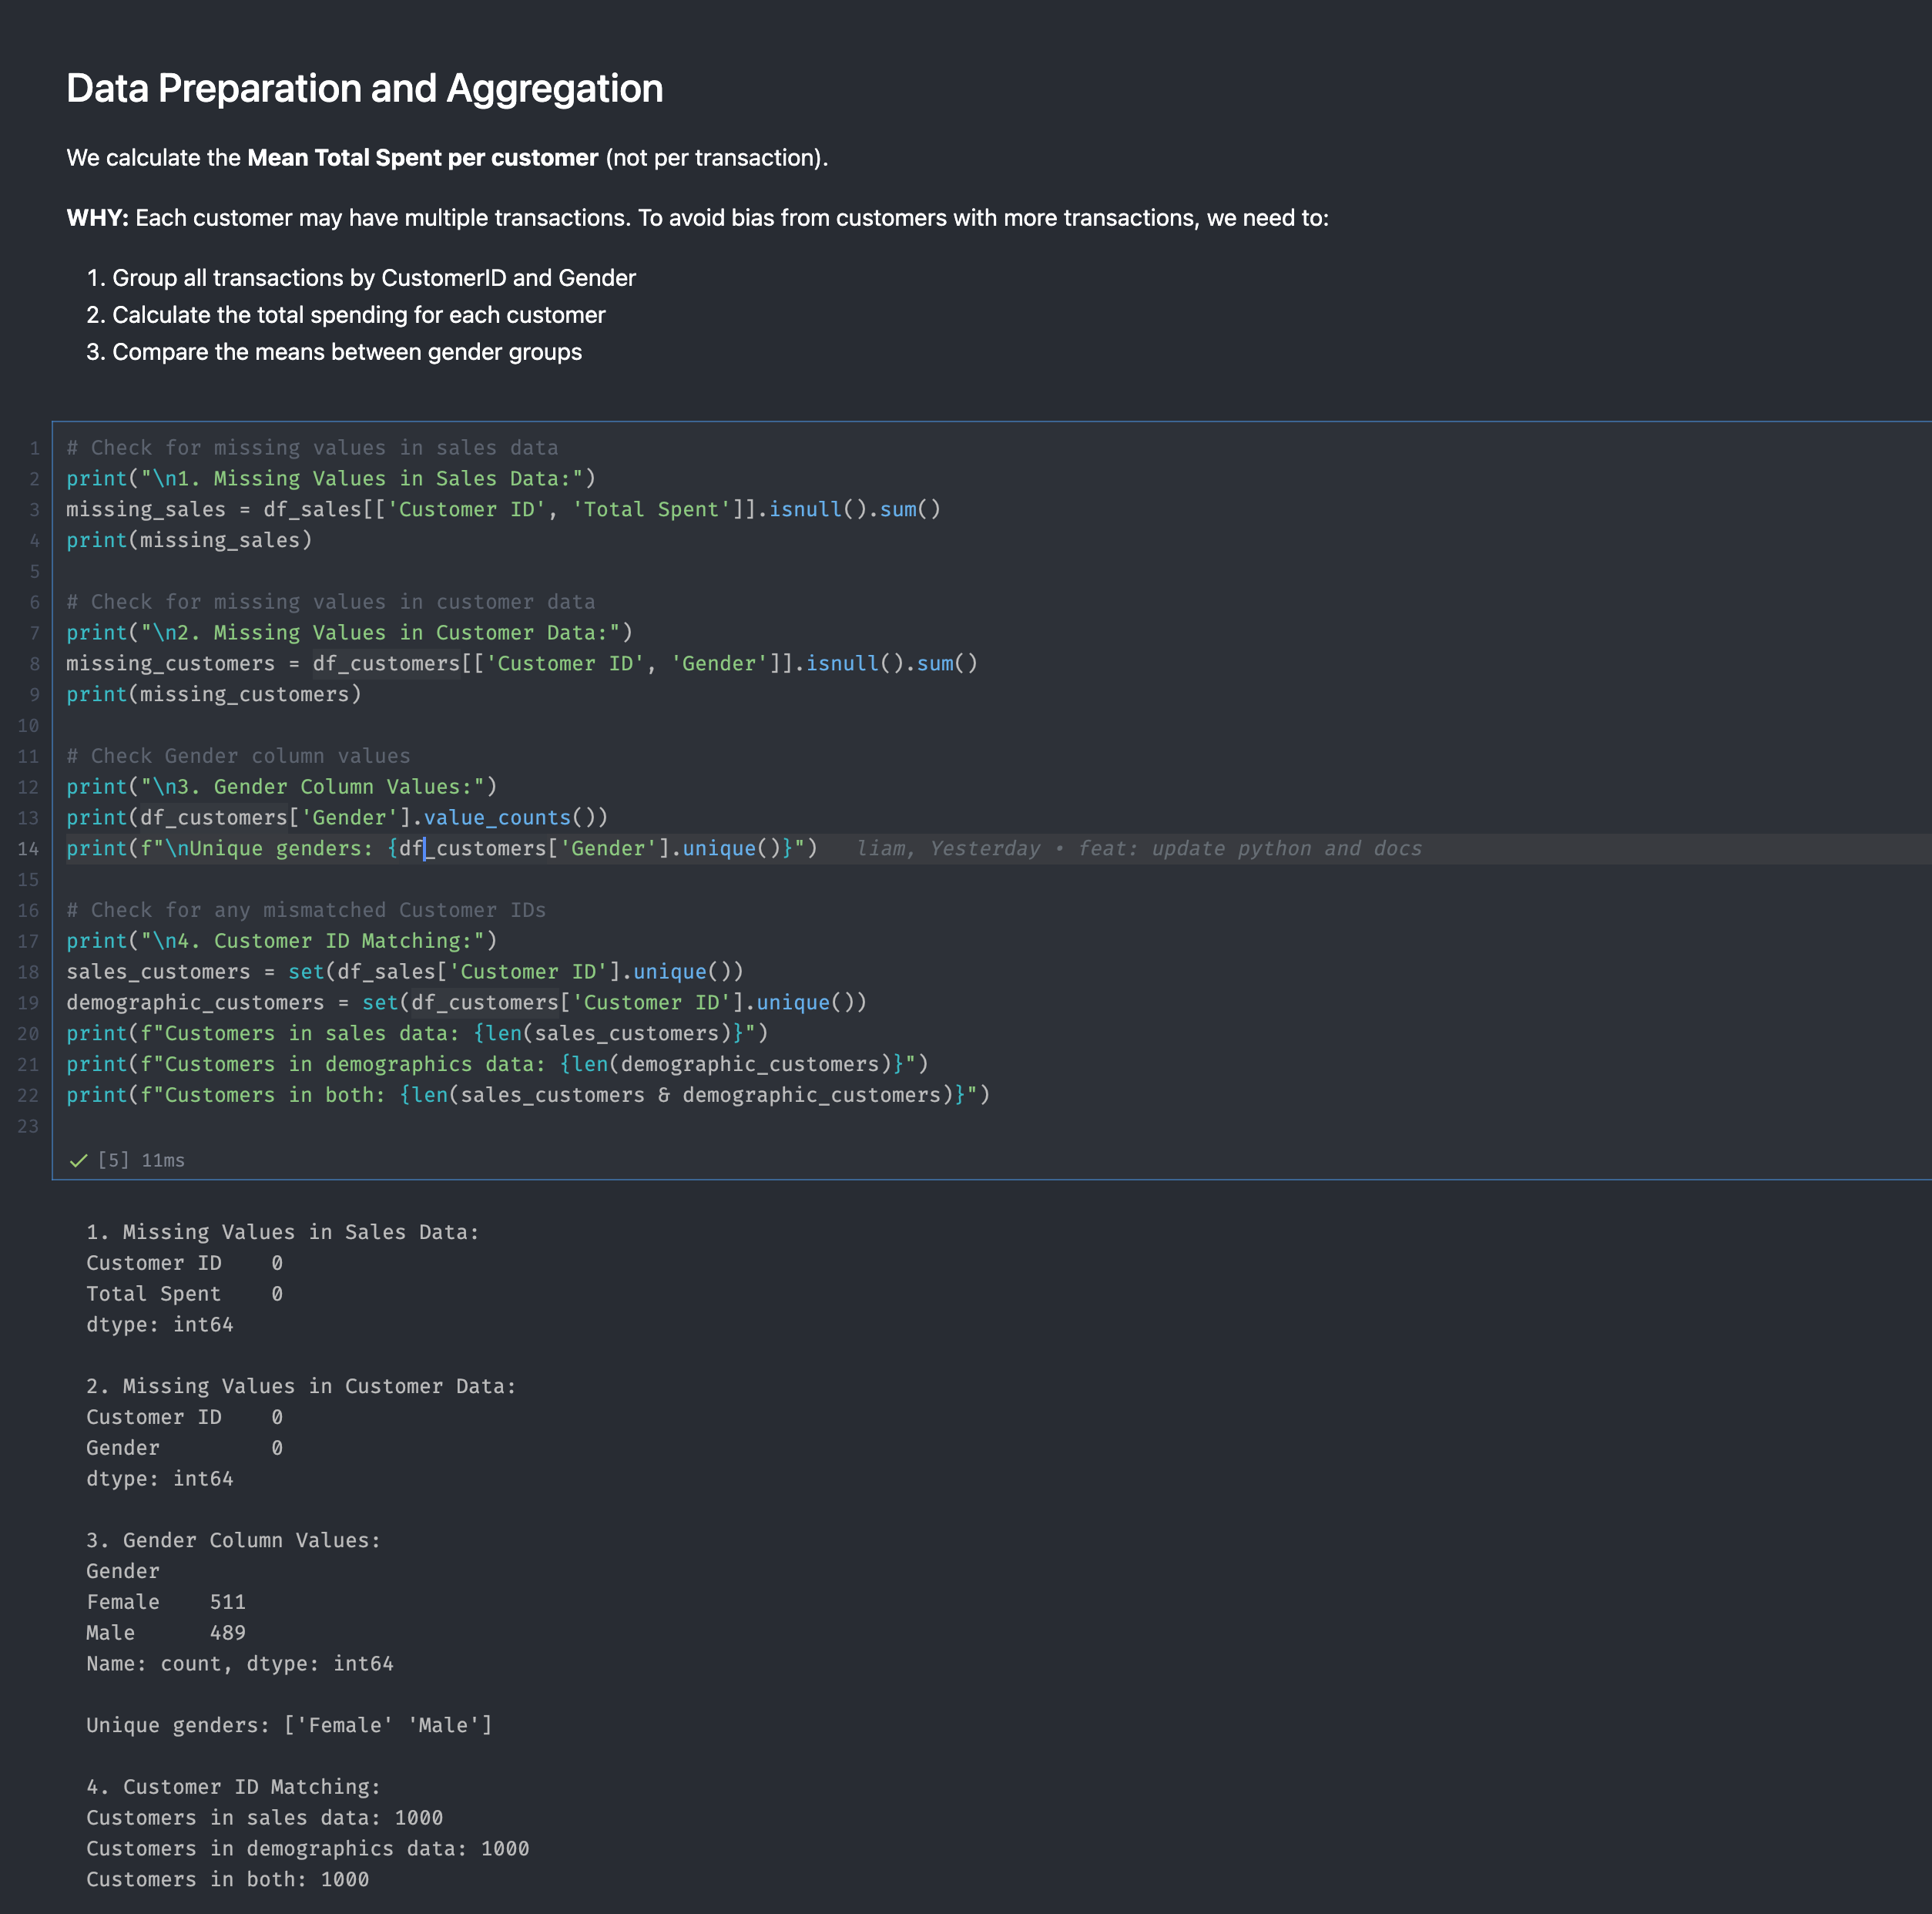

After checking the data, we continue to merged 2 dataset Sales and Customers and calculate Total spent per customer and extract statistical data

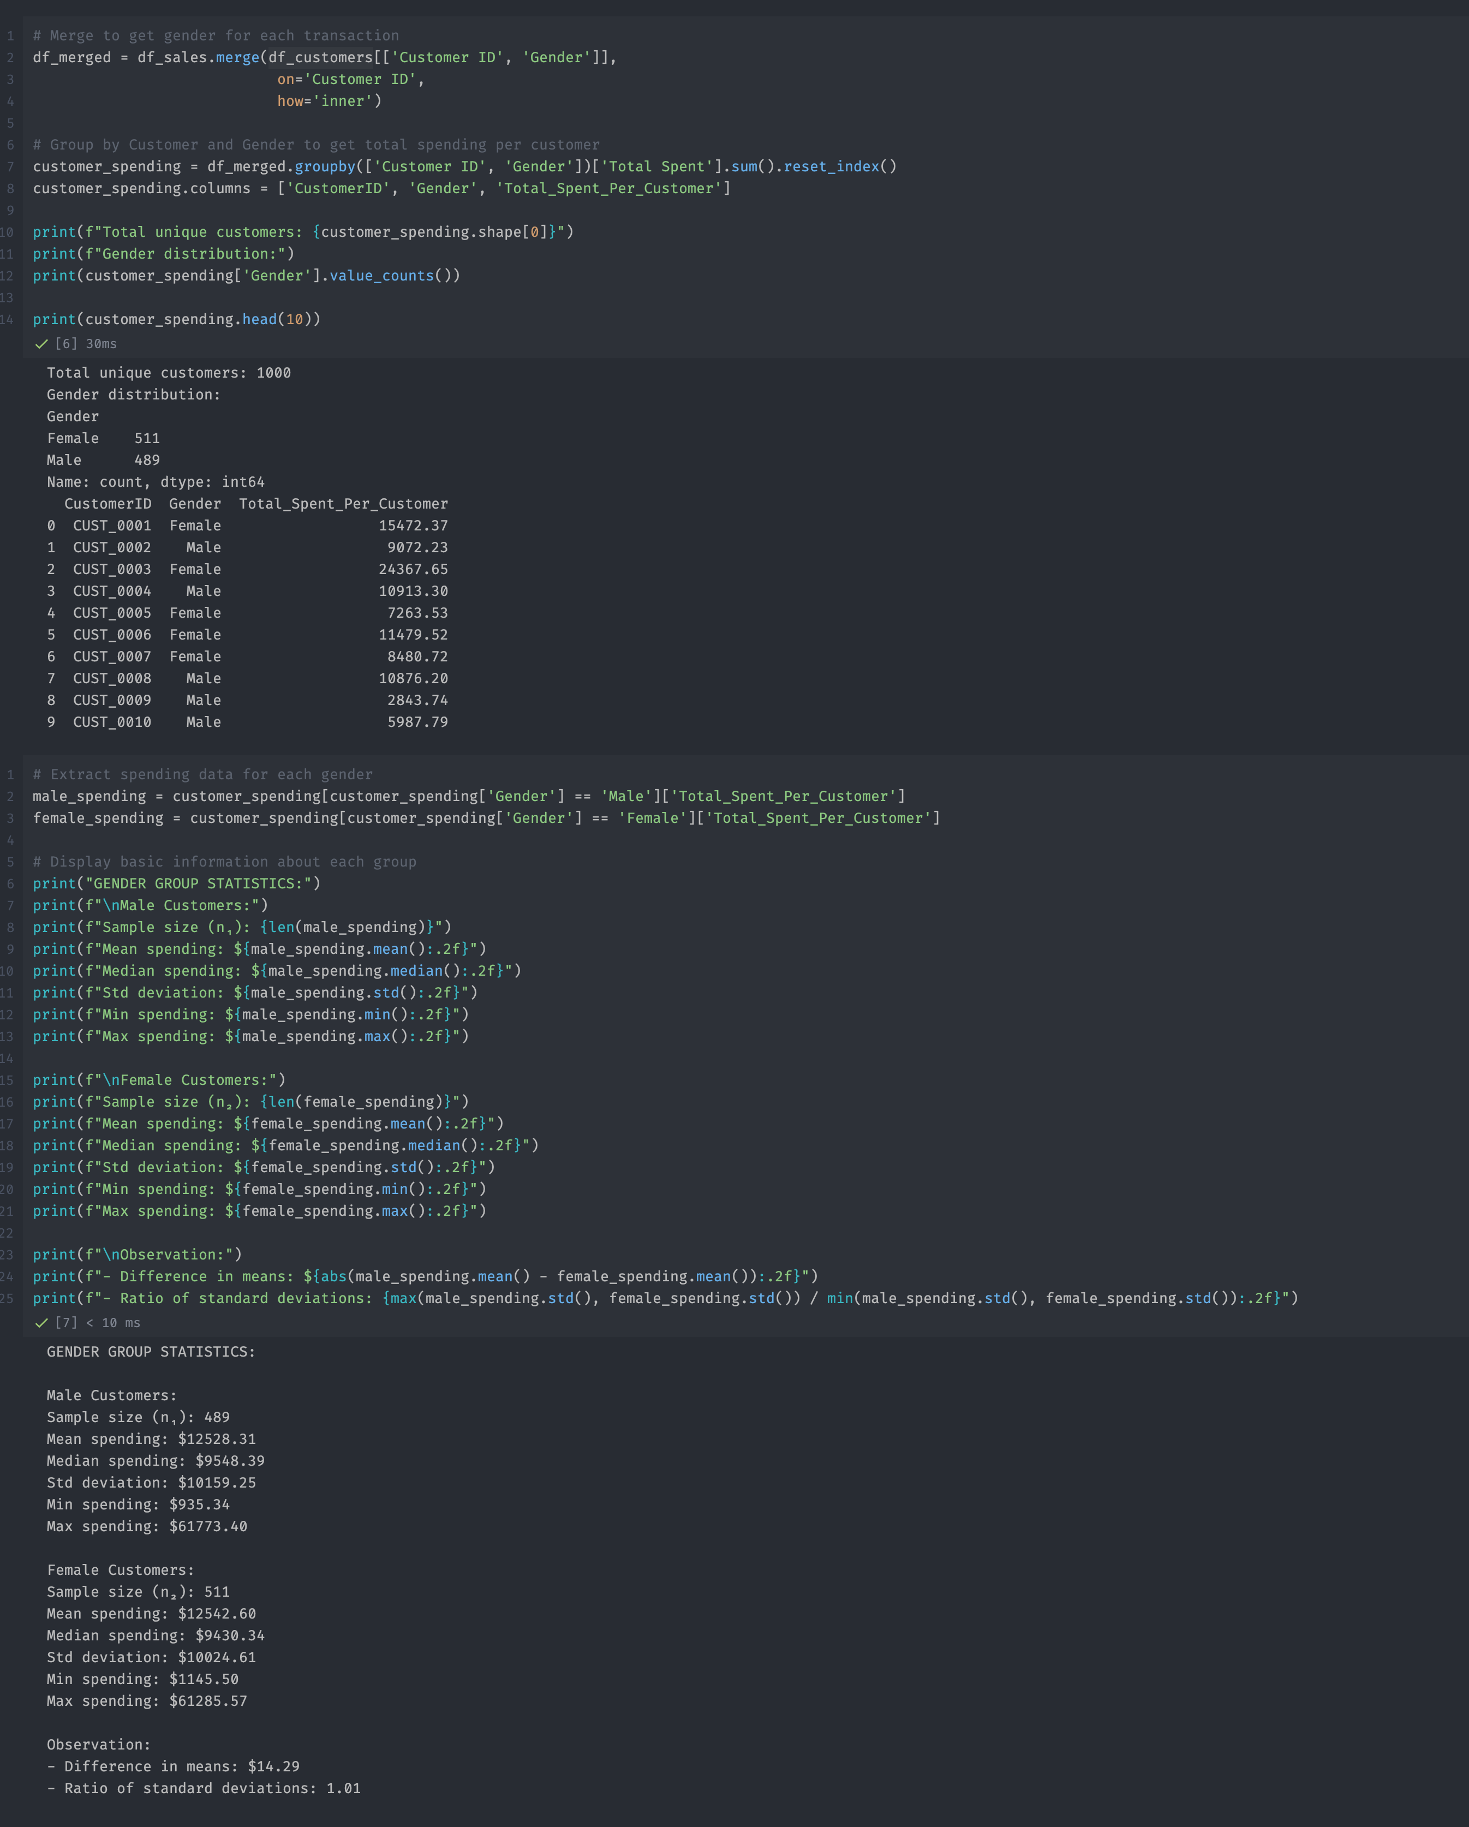

Once the data is valid, we start to analyse and work on the hypothesis testing base on the hypothesis testing report we did above

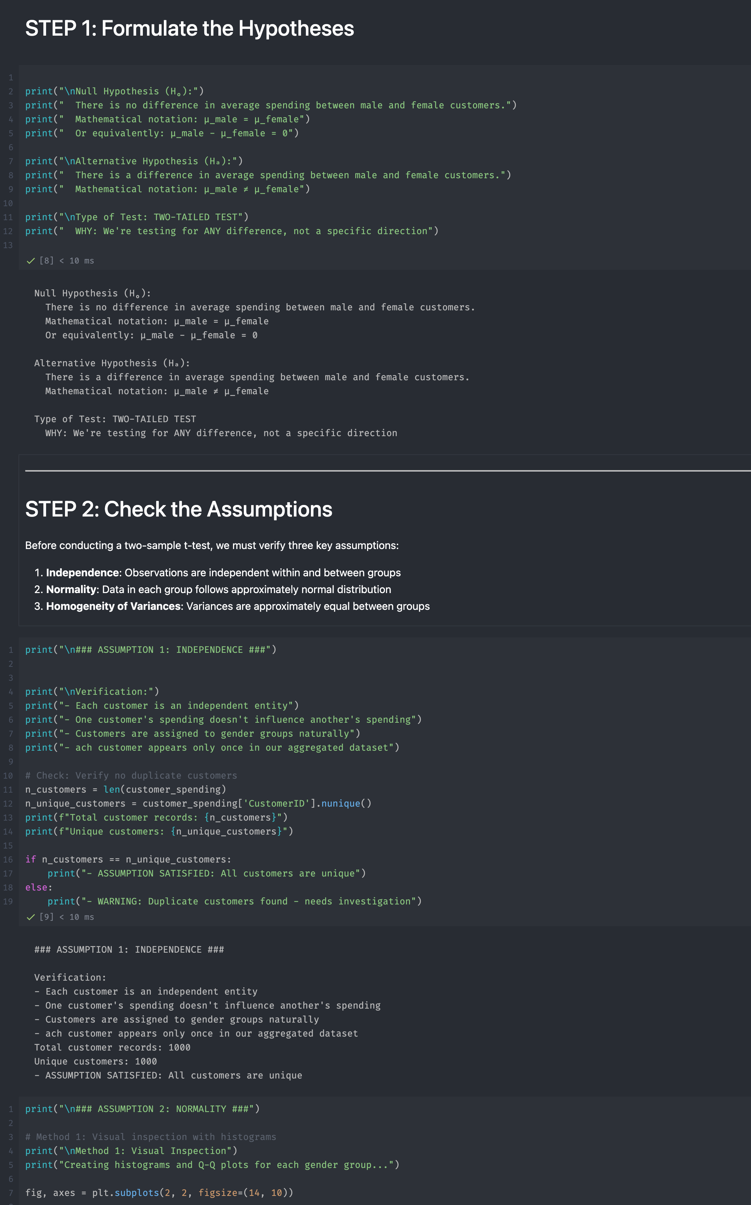

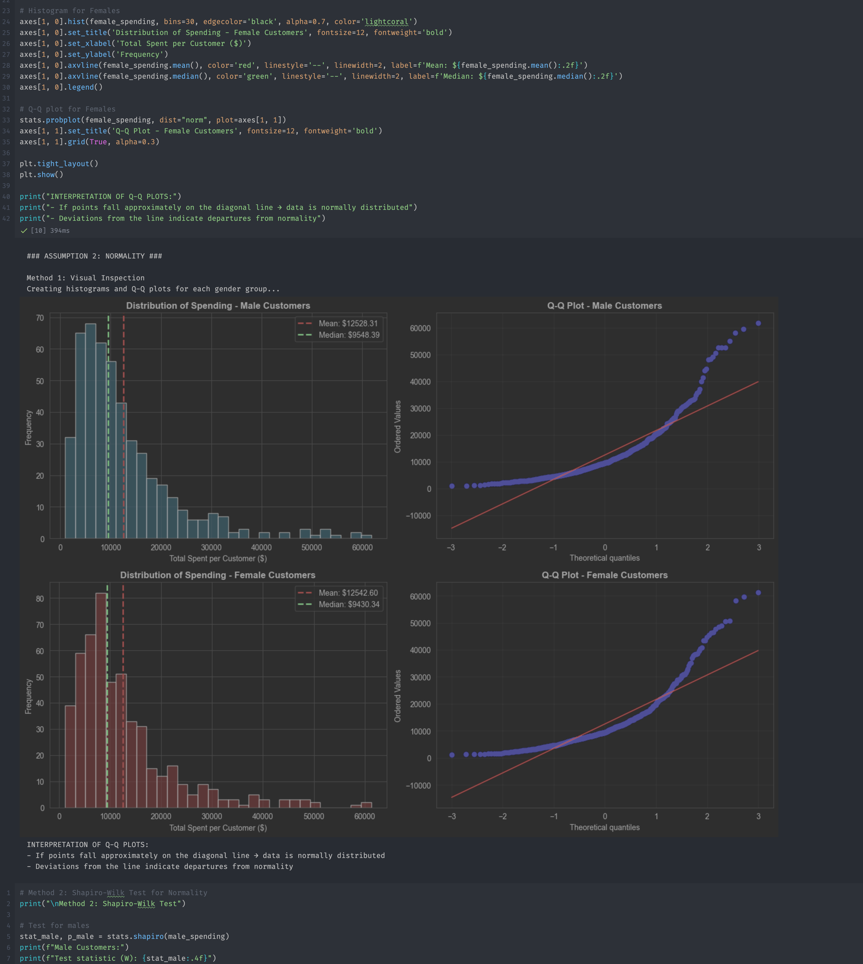

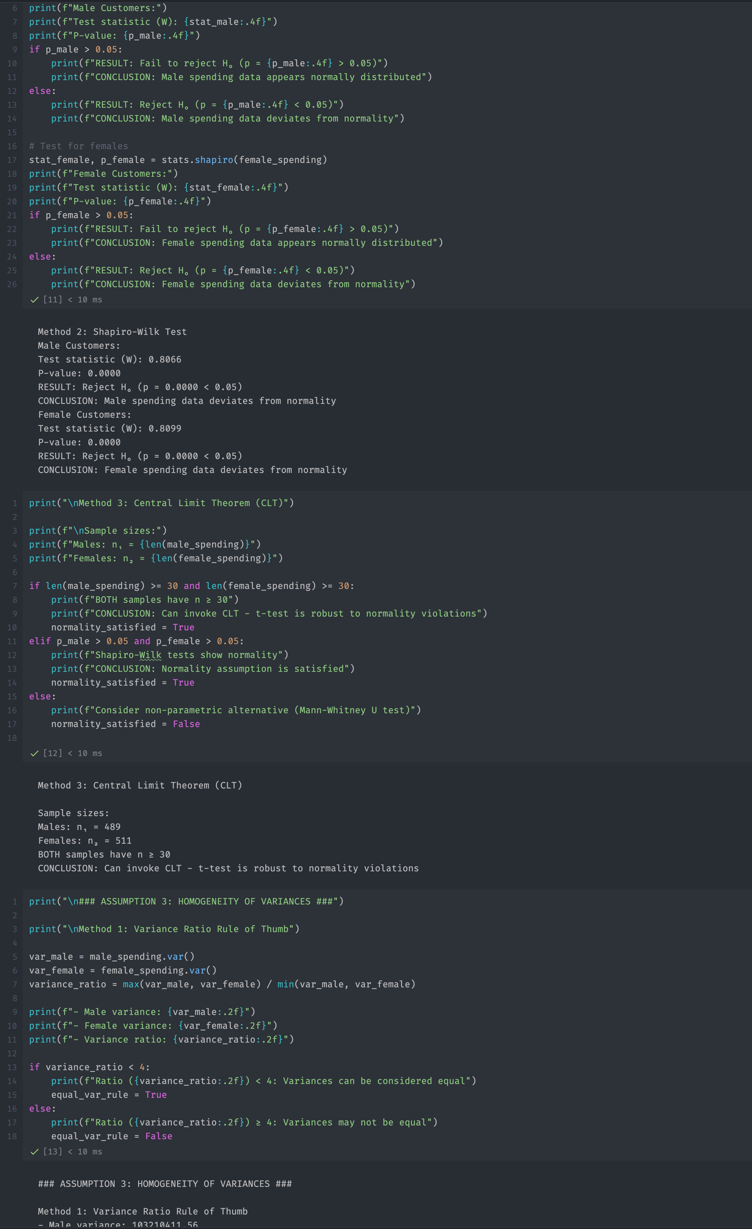

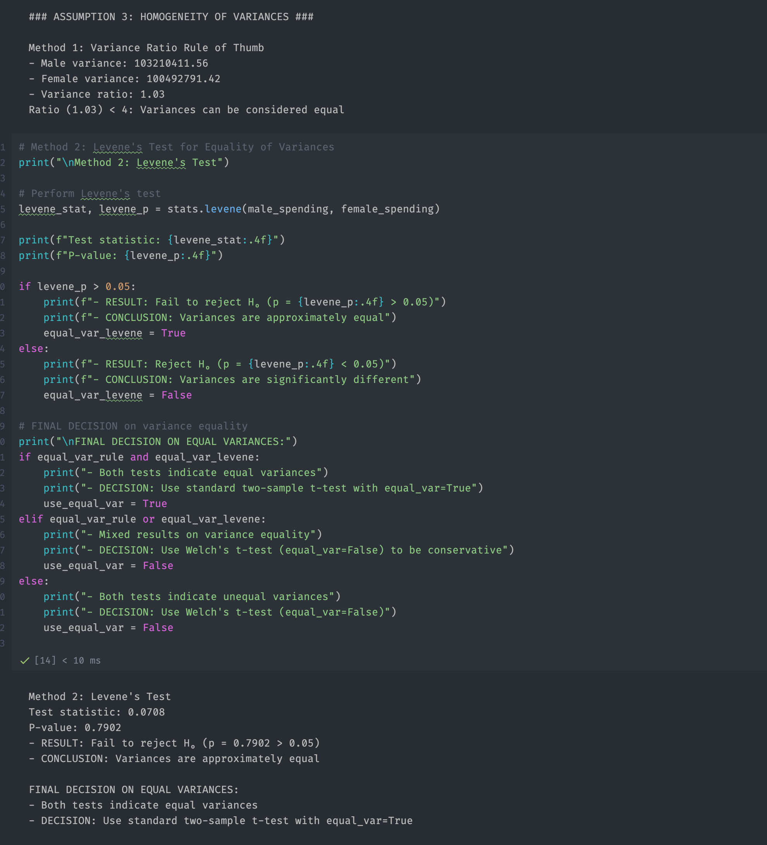

After we verified the assumption, we started to conduct the test

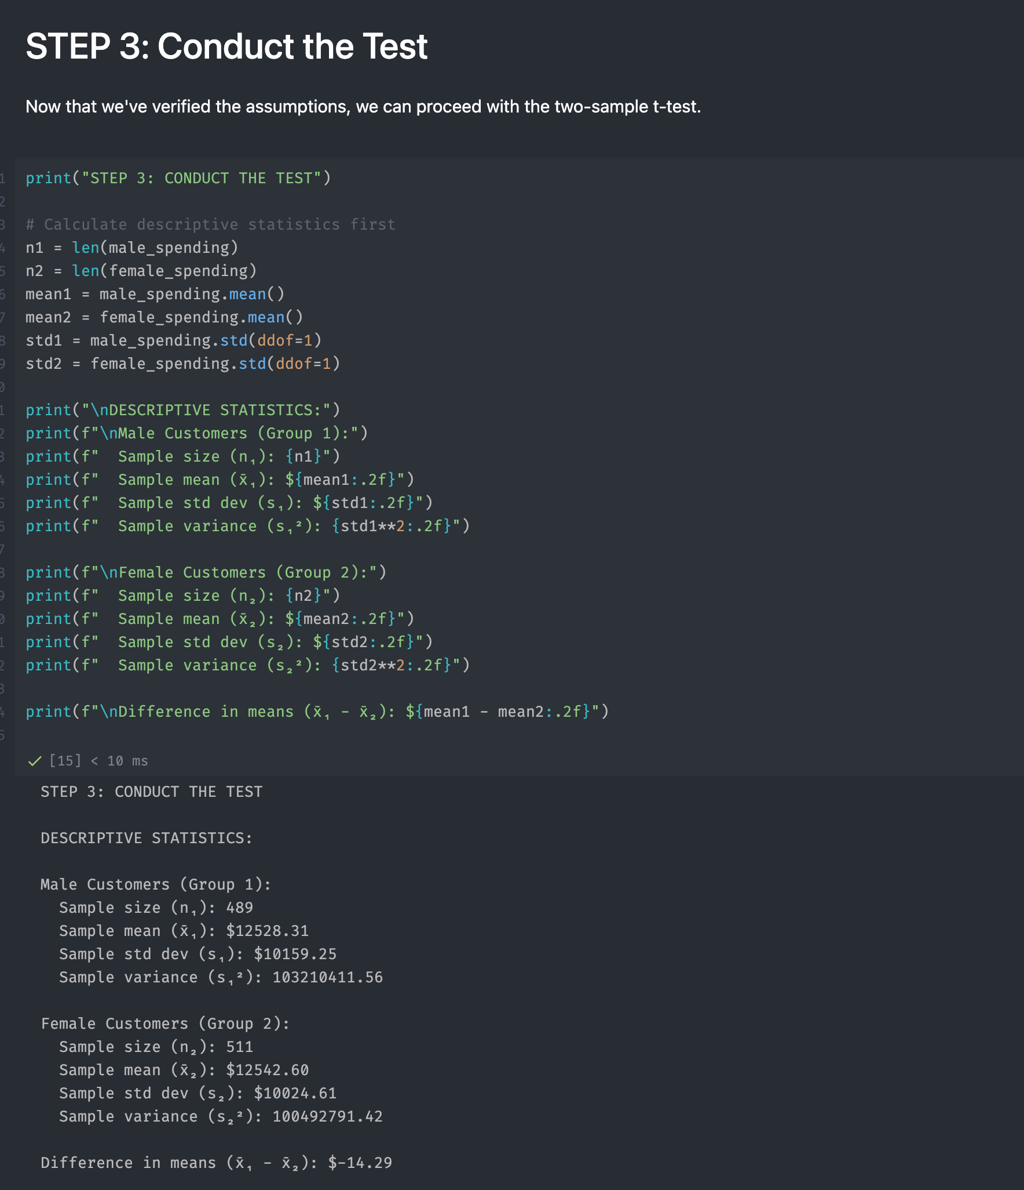

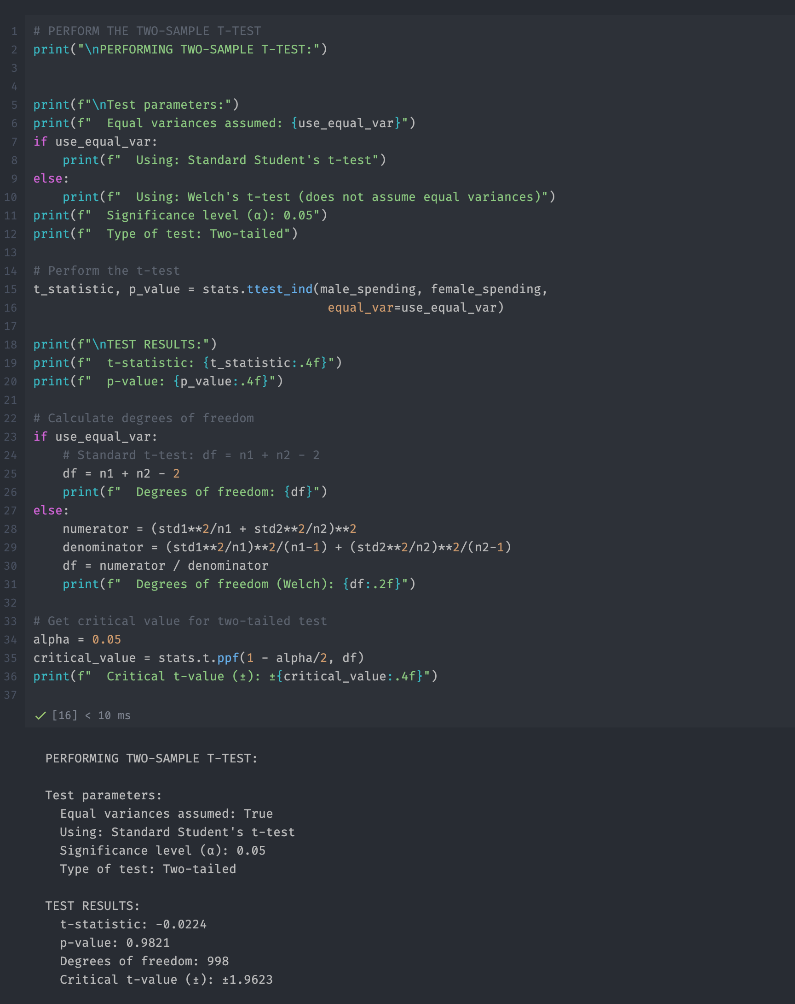

Once we calculated the t-test and got the result, we continued to calculate the p-value and gave the conclusion

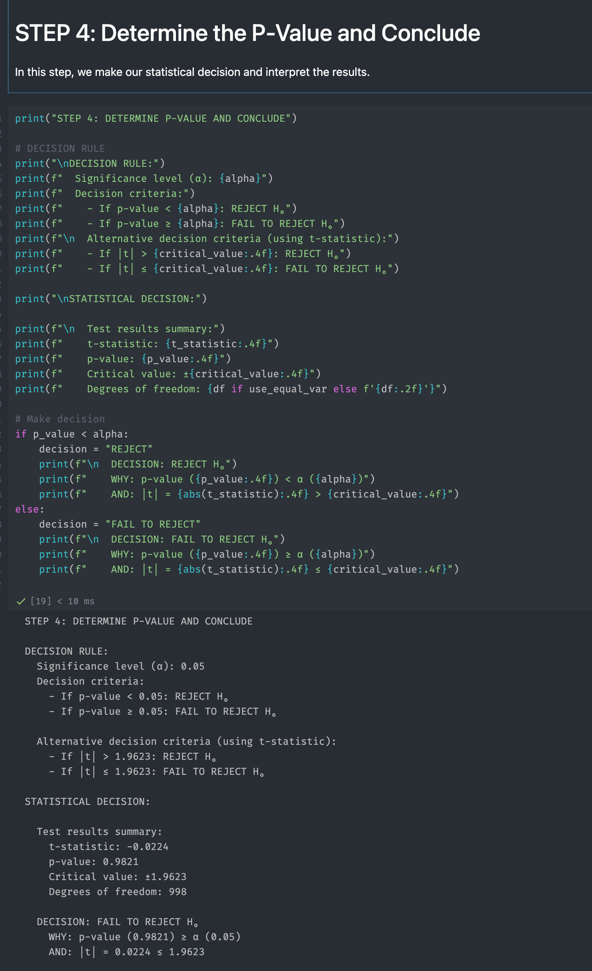

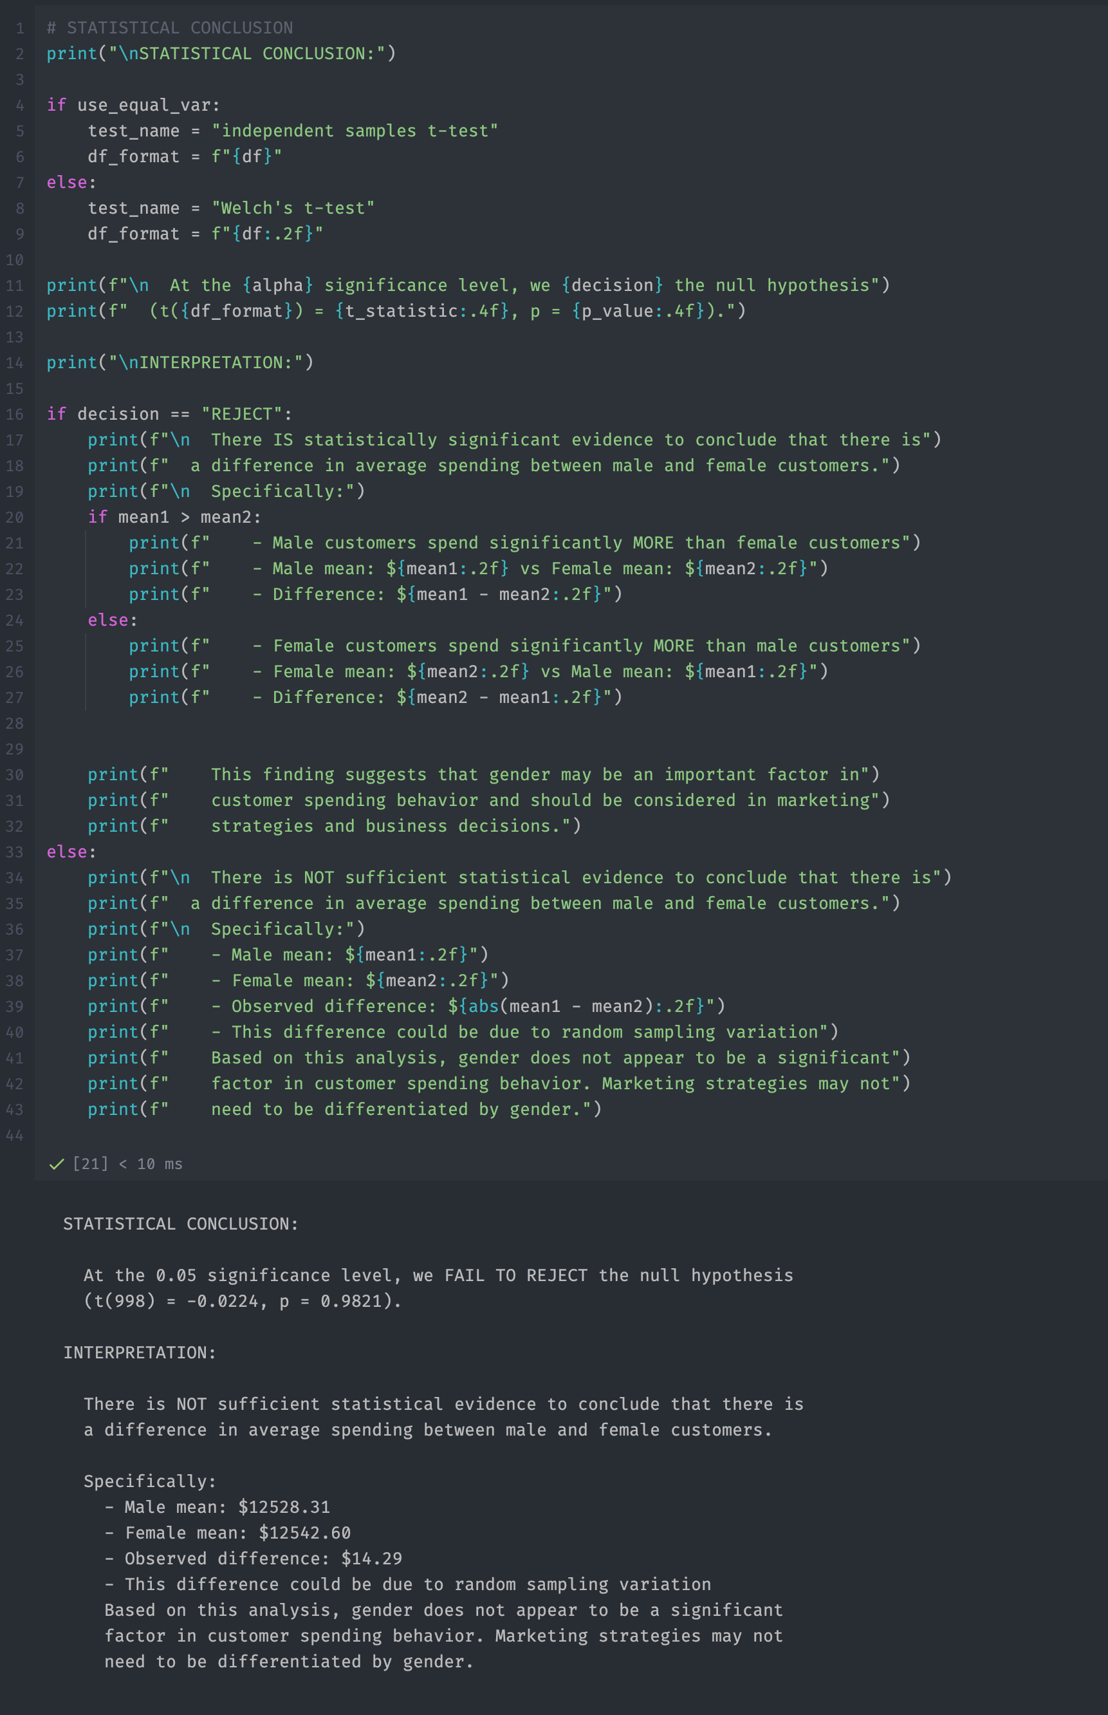

After that, we calculated the Confidence Interval and gave our verdict with visualization

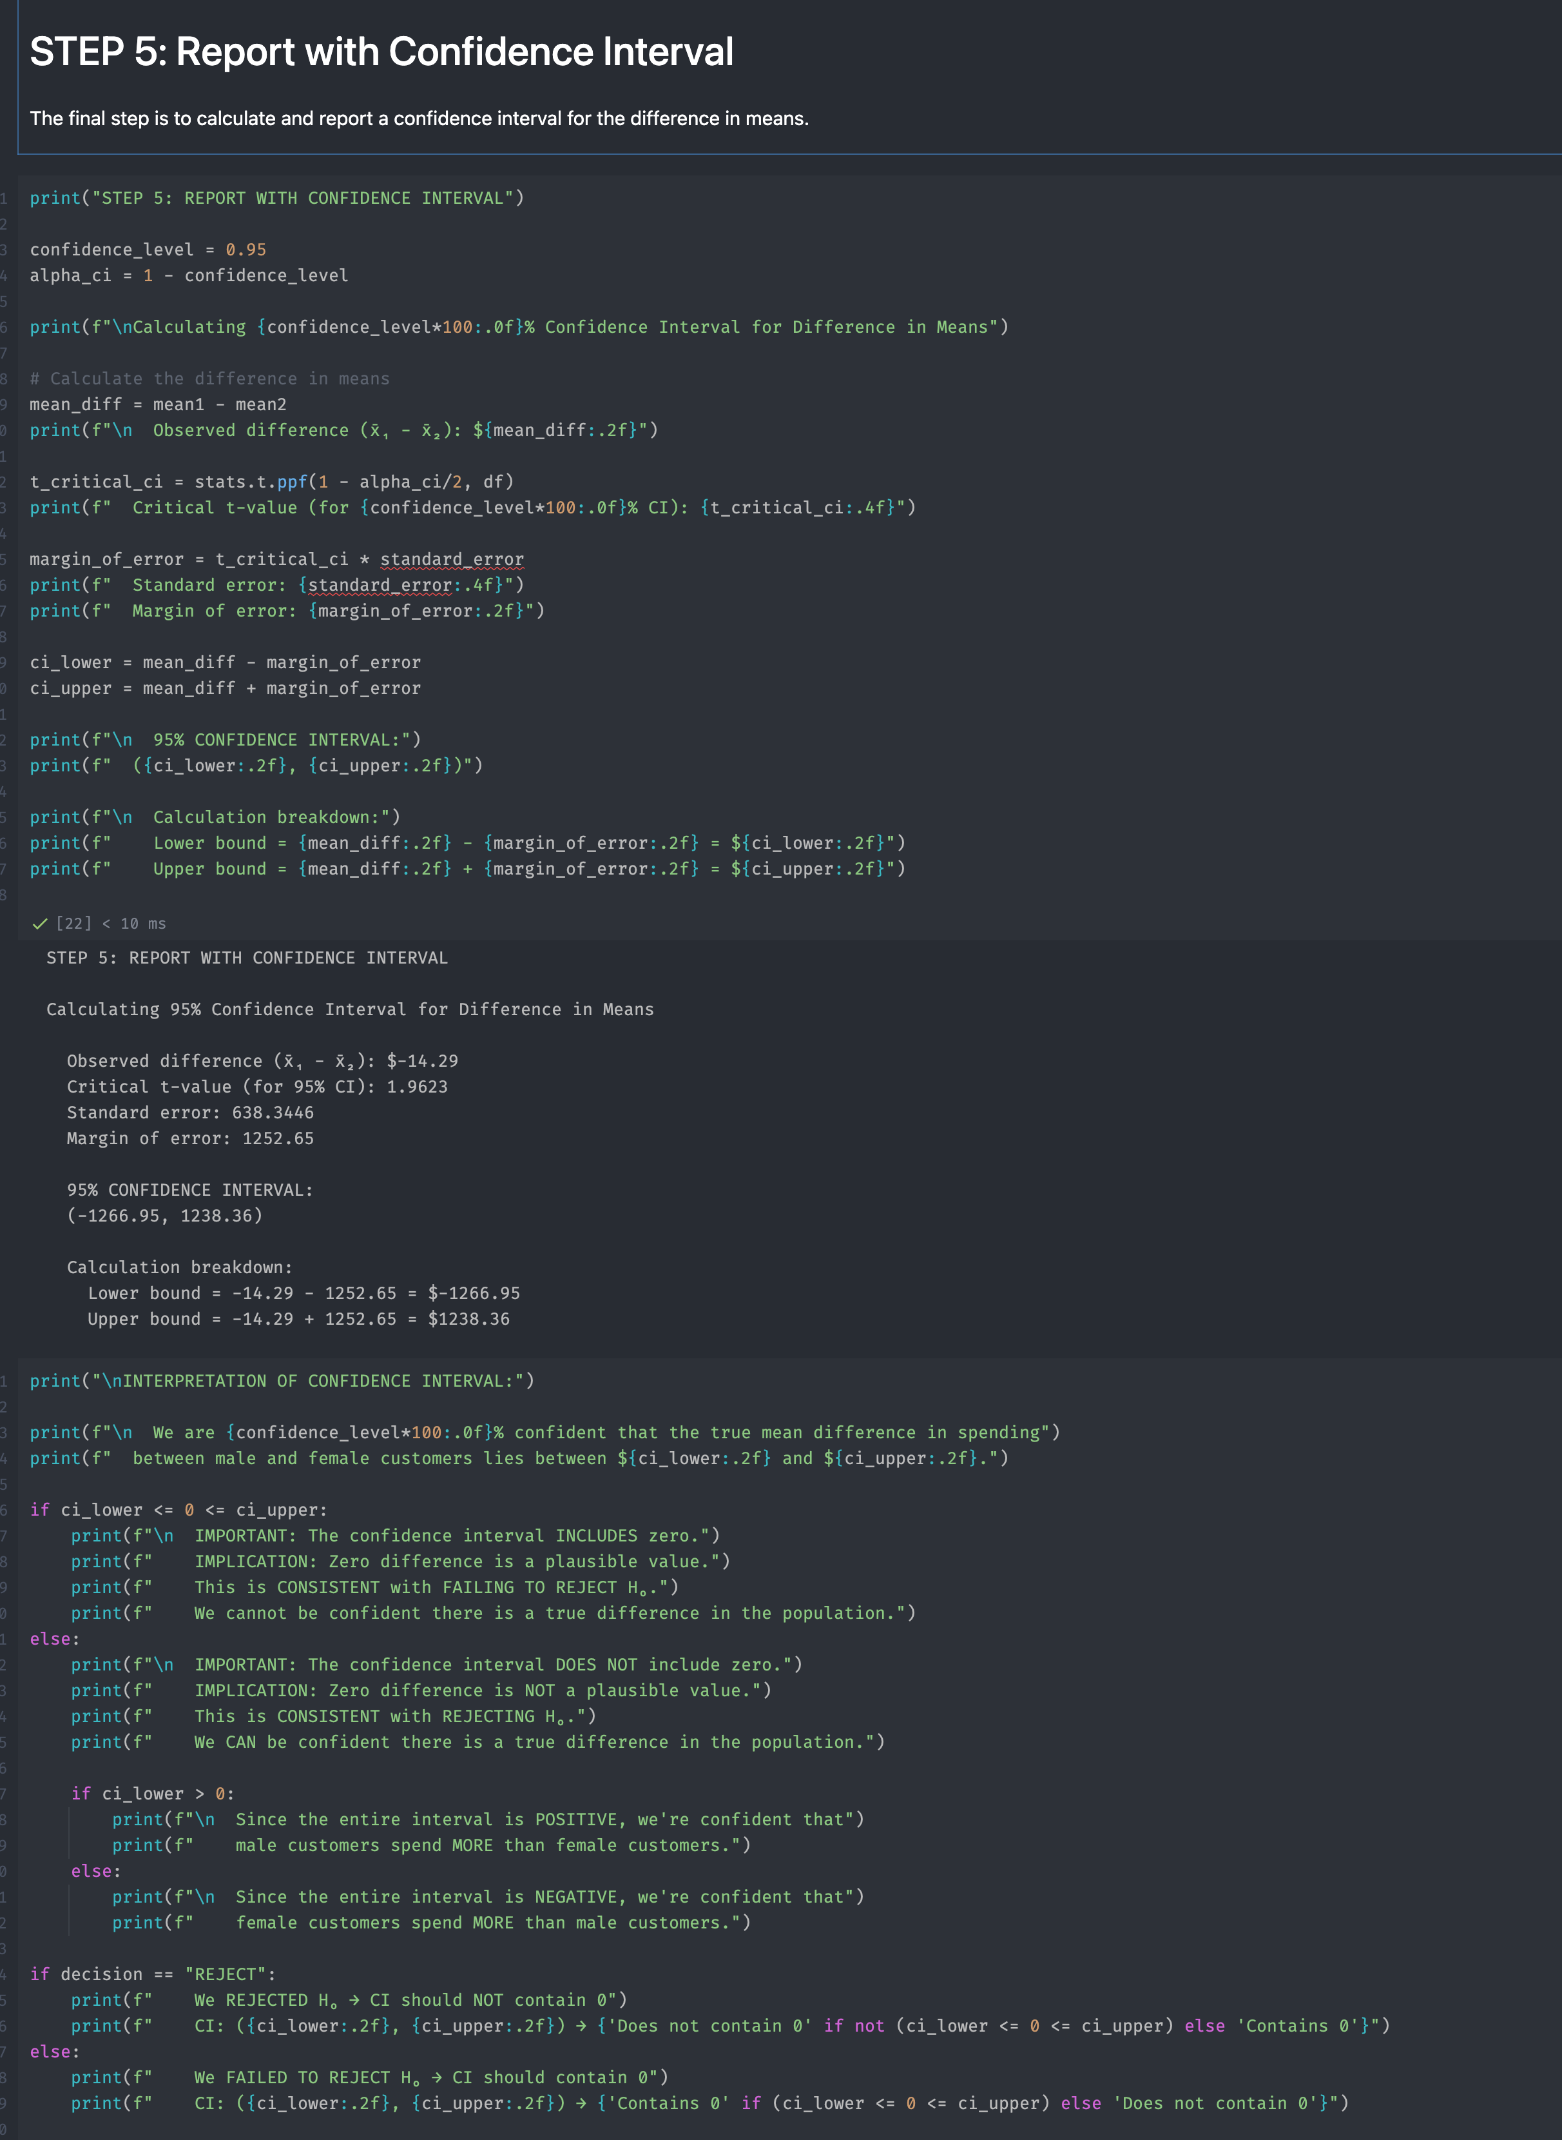

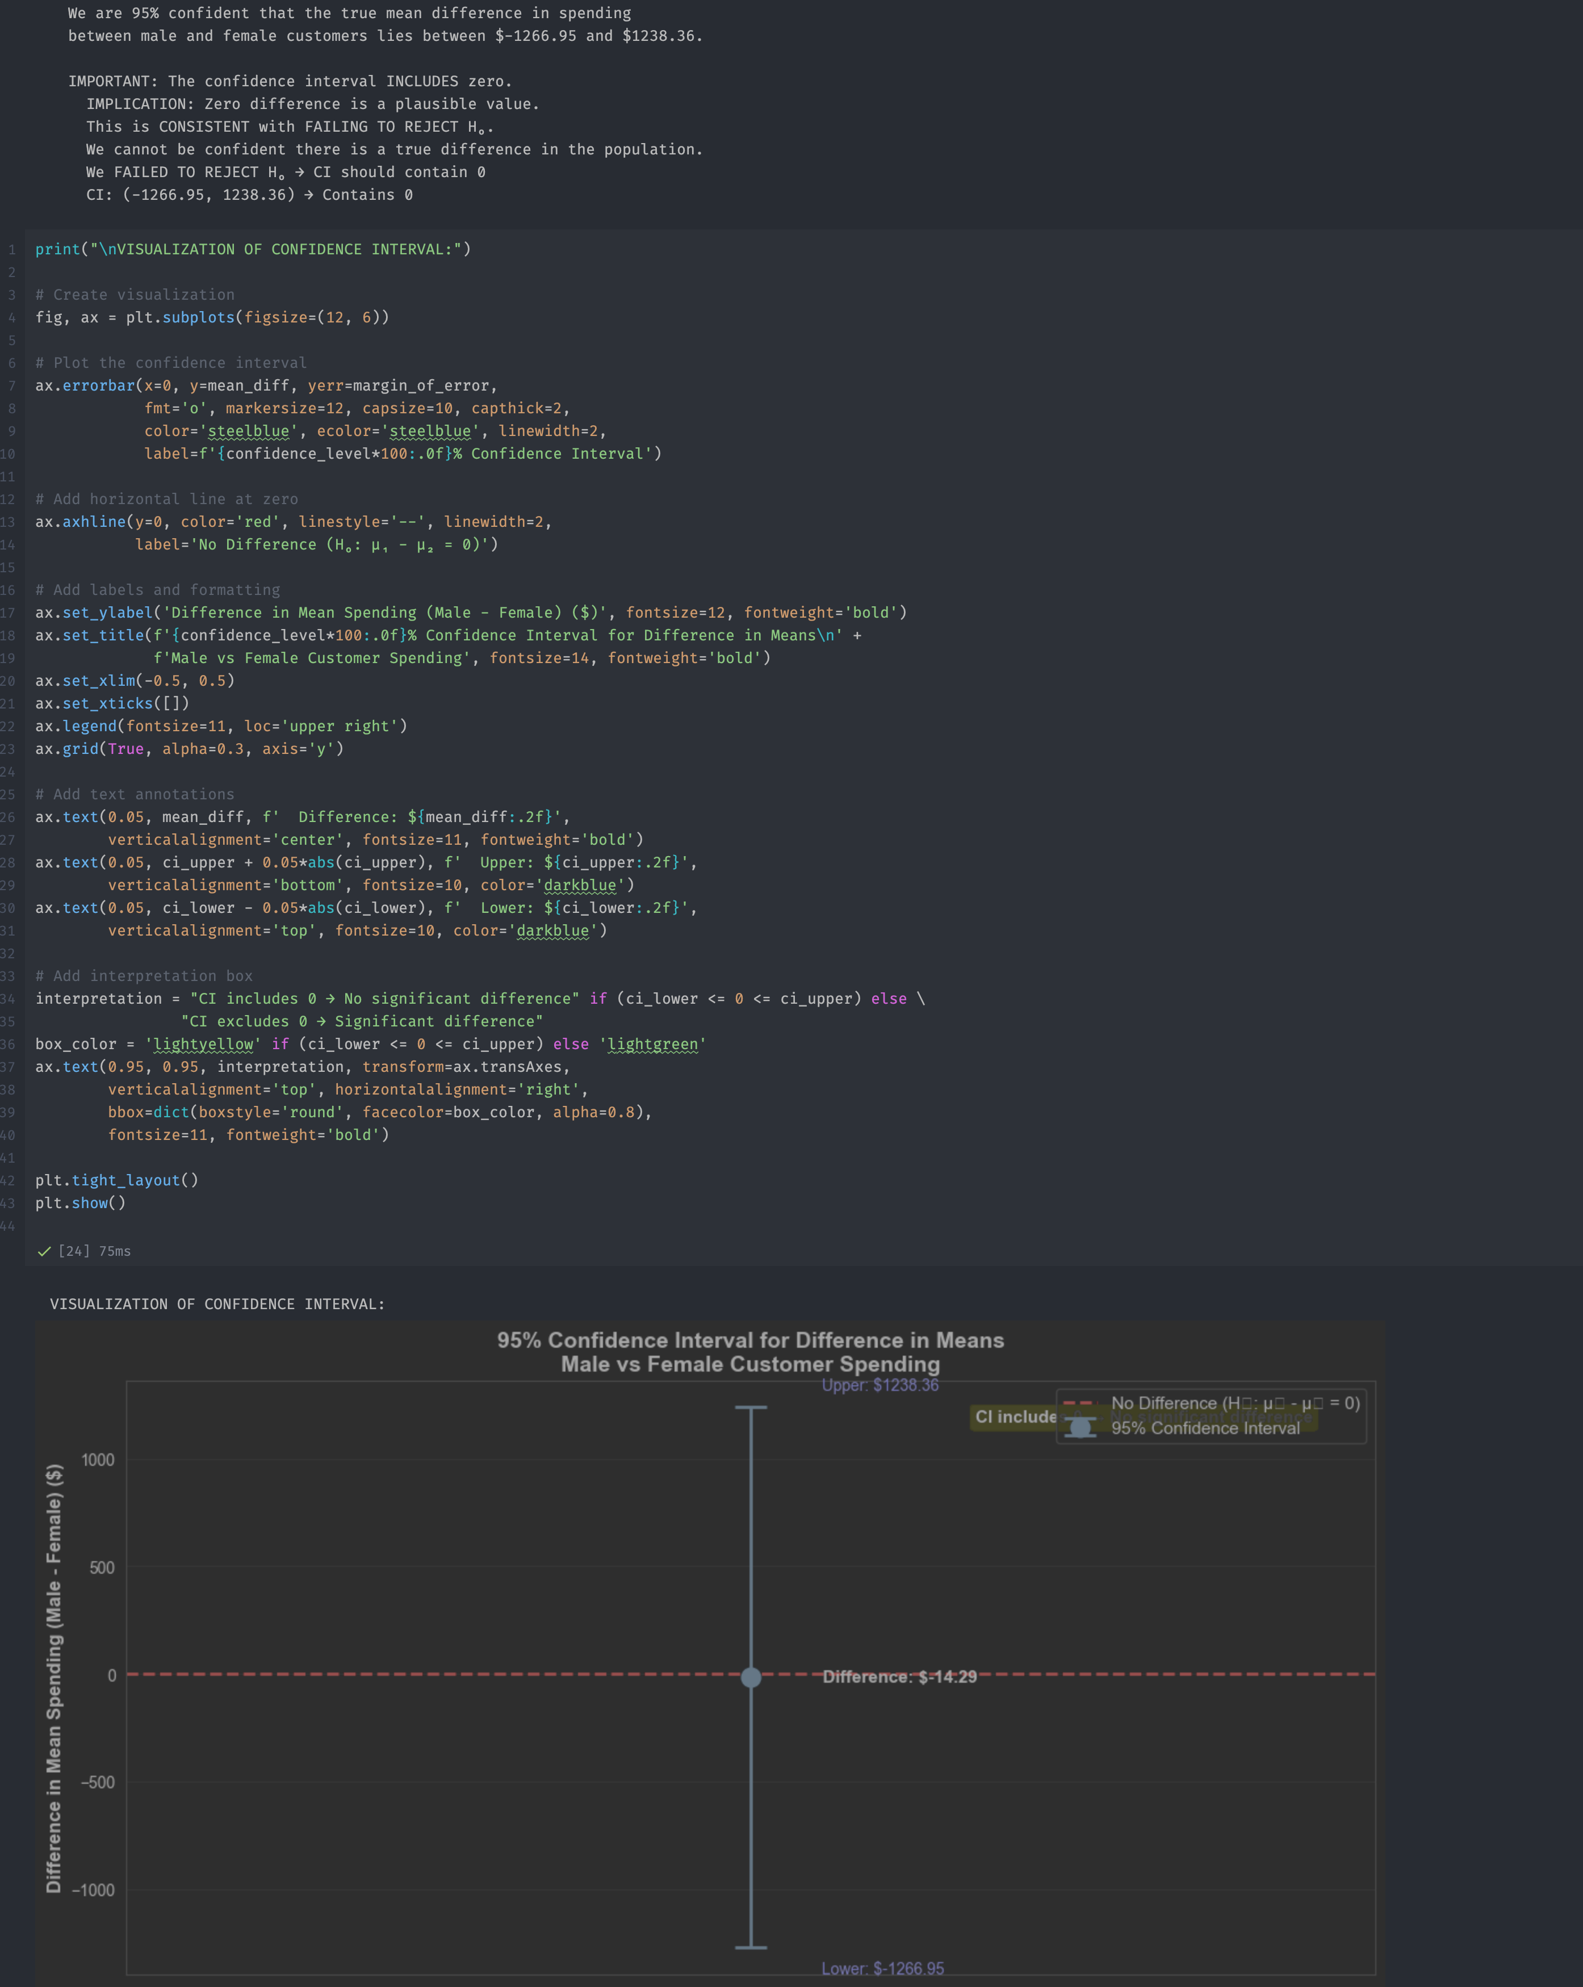

Finally, we concluded and gave our report

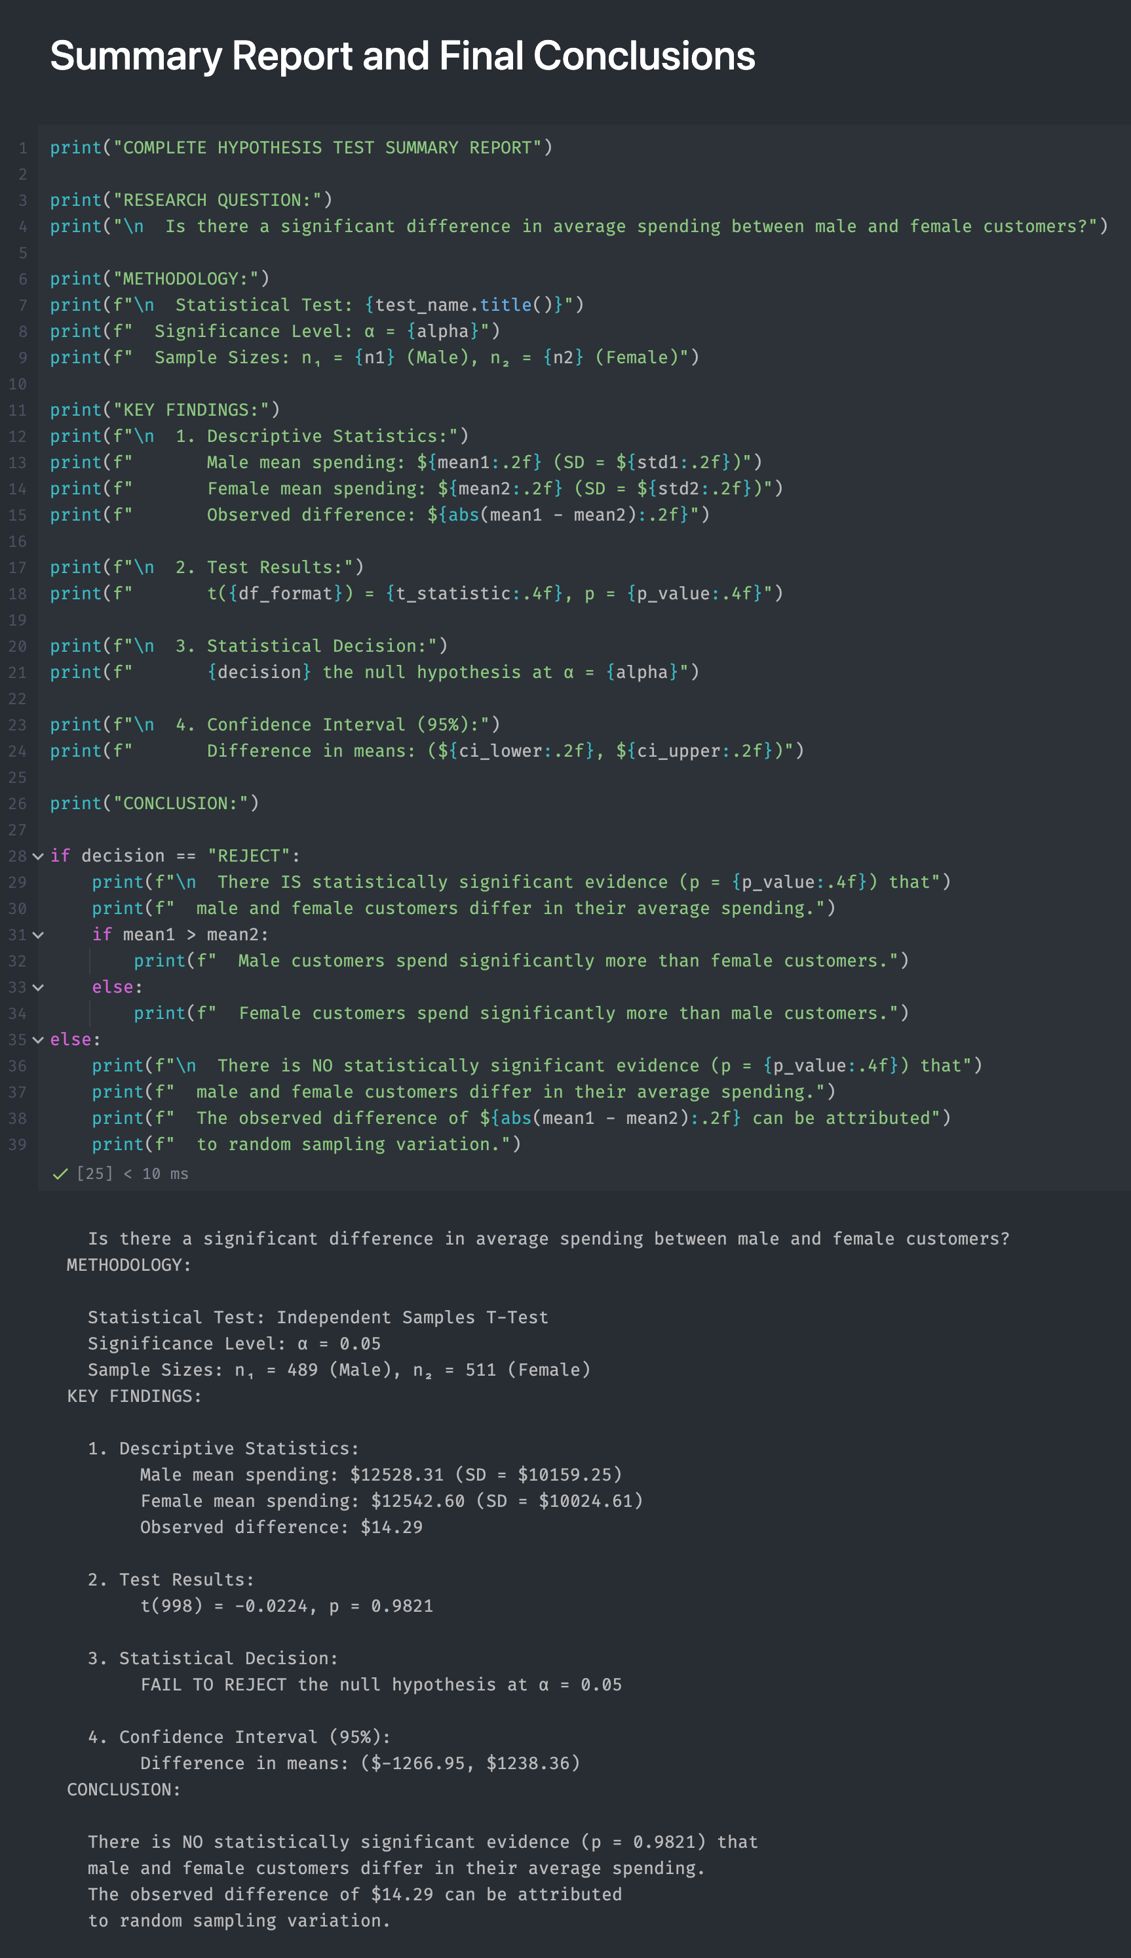

# Hypothesis testing Using Excel

## Hypothesis 2: Gender Differences in Spending

For the excel, we did the same with the hypothesis report above.

The structure of the excel’s sheet:

* Customers: the original customers dataset
* Sales: the Sales dataset that used in deliverable #2
* Sales_with_Gender: the dataset that is the combination between Sales and Customer’s Gender in Customer dataset
* Analysis: All the hypothesis analysises from step 1 to step 5

**Implementation details:**

1. First, we imported 2 datasets: Customers and Sales into the excel
2. We created a new sheet named “Sales_with_Gender” by copying entire Sales datasets and using Vlookup formula to fill the new column named “Gender” in the sheet
3. From that, we create a new table in Customer_Spending_Summary with 3 columns are “Customer ID”, “Gender” and “Total_Spent_Per_Customer”
   1. Customer ID: We copied entire Customer ID from Sales Dataset and remove duplications
   2. Gender: Using Vlookup to find the correct customer’s gender from the “Sales_with_Gender” sheet
   3. Total_Spent_Per_Customer: We used SUMIF function to calculate base on the Customer ID and Total Spent in the “Sales_with_Gender”
4. We created a new sheet named “Analysis”
   1. We created a table with 2 columns are Male_Spending and Female_Spending that only shows the Total_Spent_per_Customer from the “Customer_Spending_Summary” base on the Gender
   2. From that table, we can do the hypothesis testing
      1. With the step 2, we created a histogram based on 2 columns “Male_Spending” and “Female_Spending”
      2. We also used Data Analysis Toolpak to generate statistical results in step 2 and step 3

